Hypnopaedia Today
Student’s name
Professor’s name
Institution
Course

Hypnopaedia Today
Appeal to Need for Attention
Hypnopaedia is the principle of sleep teaching. People are taught while under hypnosis or when they are asleep. A recorded lesson is played repeatedly while a person sleeps. It can fail, because the person might not associate the lesson learned with questions asked later when they are awake. In Brave New World, hypnopaedia is possible, but the citizens of the new world can only learn moral education. Although Little Reuben can narrate about the Nile being the longest river, he cannot associate that with the question about the longest river. Moral education worked because it was not rational. He explains “Whereas, if they’d only started on moral education … moral education, which ought never, in any circumstances, to be rational (27)”.The director believes hypnopaedia is useless for intellectual training since children can repeat the word, but do not know what they mean. In this new world, hypnopaedia is used to condition citizen from when they are infants to lose individuality and behave exactly like they are programmed to. The Director explains, “We condition the masses to hate the country … but simultaneously we condition them to love all country sports… (24).” After the programming, people hate what they are programmed to hate and love what they are programmed to love. They consume what conditioning allows them to consume.
Jib Fowles argues that people are motivated by something primarily primitive that invoke consumer’s drives and longings. Unfulfilled urges and motives are what pressures humans to make decisions, most of when it comes to buying products. Need for attention is one of the commonly used appeal to lure in buyers, most of to buy clothes, cosmetics and lotions. People desire to exhibit themselves in a way that arouses primitive instincts. Although some clothes such as underclothes are meant for men, most adverts are meant for women, who want to be objects of fascination. Food is also sold that way by using fit people who convince their audience that their bodies are from eating healthy.
 This is a type of makeup, lipstick to be precise. It is meant to make the woman feel like people are focusing on her because her appearance is amplified. It feeds into the woman’s love for attention.
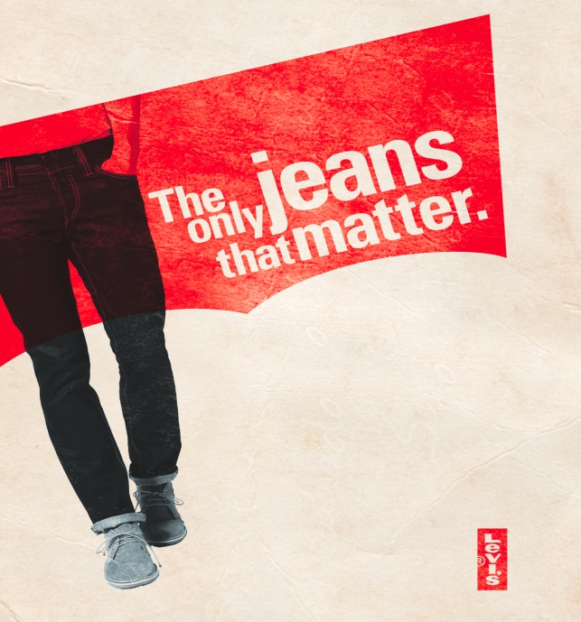 This advert is meant to appeal to the man’s need for recognition and attention. He will feel validated because the jeans are all what matters, which guarantees him attention.
 This ad makes women feel desirable and attention worthy if they can look like that.
 This image can be used to encourage people to get some type of bodies, which are linked to attention. People avoid calories when they do not want to appear in a certain way.
 In Romance, people want to please others and be seen by their significant others. This is centered on attention seeking.

References
ADVERTISING APPEALS (OVERVIEW). The Visual Communication Guy. (2017, October 9). https://thevisualcommunicationguy.com/business-communication/advertising-appeals-overview/.
Hsiao, K. (2016, February 15). The "need for attention" appeal when selling cosmetics. Medium. https://medium.com/@khsiao6210/cosmetics-in-advertising-generally-are-focused-more-towards-women-than-men-9340756d34d.

